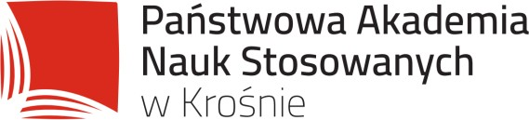

Reviewing procedure for the scientific journal HERBALISM

The reviewing procedure is in accordance with the recommendations of the Ministry of Science and Higher Education described in the brochure “Good practices in reviewing procedures in science.”

All scientific and didactic publications published by the Publishing House of the State University of Applied Sciences in Krosno are subject to the anti-plagiarism and review procedure.

- Internal review is the initial stage of qualifying a text for publication and concerns the substantive and technical assessment of the work. The internal review assesses the following:
- compliance with formal requirements (i.e. submission of a form for publication containing a description of the publication, its purpose, justification for publication, and submission of complete materials)
- selection of the topic,
- originality of the publication,
- scientific relevance of the publication,
- didactic importance of the publication,
- market demand,
- technical preparation of the work.

- External review – the text of the publication is sent for external review after a successful application for publication and passing the anti-plagiarism procedure.

- the editors require that each article be submitted electronically,
- when submitting a paper, the author(s) shall make a declaration that the paper has been independently prepared,
- all submitted texts are pre-qualified in terms of compatibility with the publisher’s profile, editorial evaluation is carried out (preliminary evaluation of the content and proofreading of the text – if changes need to be made, the editors ask the author of the article to make the corrections),
- each publication is reviewed by persons outside the scientific unit in which the author(s) is (are) affiliated and outside the members of the Scientific Council. The reviewers are selected by the publishing house from among persons with recognised scientific achievements in the subject of the publication guaranteeing a reliable review,
- the author(s) receive the review and is (are) obliged to respond to it. If the reviewer’s comments are accepted, the author(s) make(s) the necessary corrections and additions to the text,

- the author(s) or affiliation of the reviewed publication are not disclosed to the reviewer (double-blind review process), or the reviewer is required to declare that there is no conflict of interest, which is considered to be the following between the reviewer and the author: direct personal relationships (kinship, legal ties, conflict), relationships of professional subordination, direct scientific cooperation in the last two years preceding the preparation of the review,
- reviews are prepared on a form provided by the publishing house,
- in the event that the review is not positive, the text may be passed on to the next reviewer,
- the publishing house reserves the right to accept or not to accept the text for publication,
- the list of reviewers cooperating with the publishing house is available on the website,
- the review should be fair, objective, reliable, constructive, consistent with the knowledge available, and performed in a timely manner.

